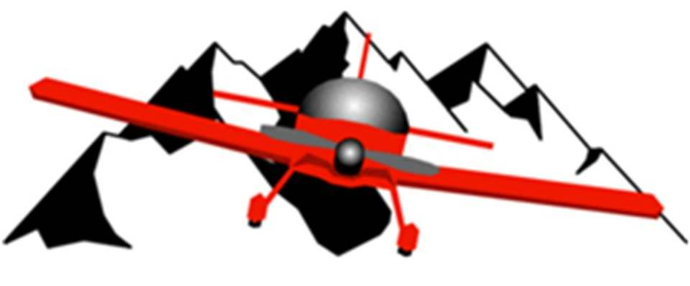

LoveAir RC Club - Pay-by-check dues payment form

Make checks payable to NCRC, Inc. or to LoveAir RC Club

Please fill out and mail this form with your check to:

Fred W Smith, Treasurer
5806 Watson Drive
Ft Collins, CO 80528

Please include Member name and AMA number
(list each pilot for family memberships)

Name AMA number
_________________ ______________________
_________________ ______________________
_________________ ______________________

Preferred Email address: __________________________
Preferred Phone number: ________________________

Postal Service Mailing address:
Street & number: _________________________________
City, State, Zip: ___________________________________

Once the AMA number of each pilot is confirmed as being current, our membership chair will send to you a membership tag which you should cut out and tape to your AMA membership card to be kept on your person when you are flying at Drake Field.

